**DB&WEB HW#3**

**19102127 ITM**

**Suho Lee**

1.

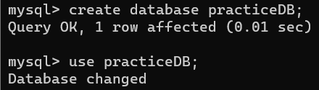

First, access to the mysql through the local. And the database name is practiceDB.

So the query should be like this ‘create database practiceDB’.

Then make sure to use the practiceDB.

2.

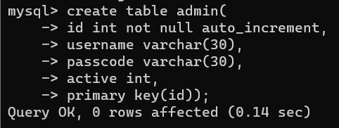

To correctly run the given php files, I made a proper database having the required schema and the corresponding some values like this.

3.

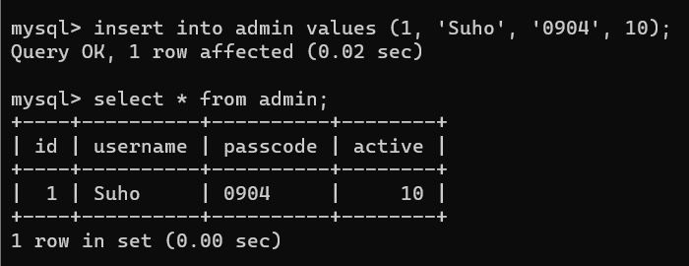

Insert four values named id(primary key), username, passcode, and active

username and passcode are used to compare with username and password during login.

active is used to expire session.

4.

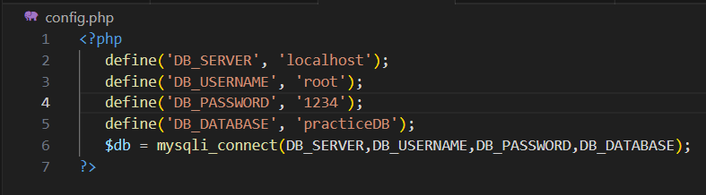

I already have set the password ‘1234’ to access the mysql.

Therefore I change the DB_PASSWORD into ‘1234’.

5.

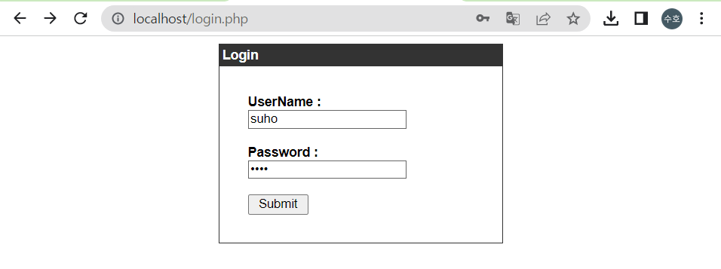

I set the username as ‘suho’ which is my name and password ‘0904’ which is my birthday.

I insert these data into username and password section.

6.

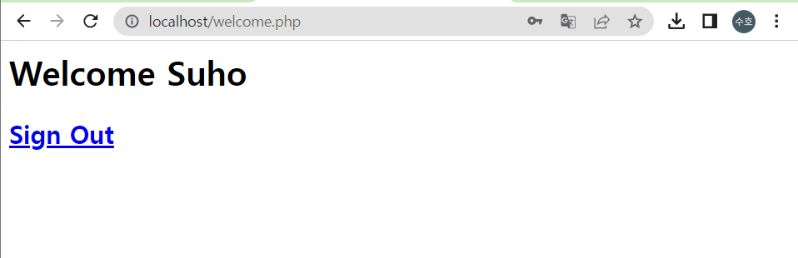

After that, the result comes out properly.

7.

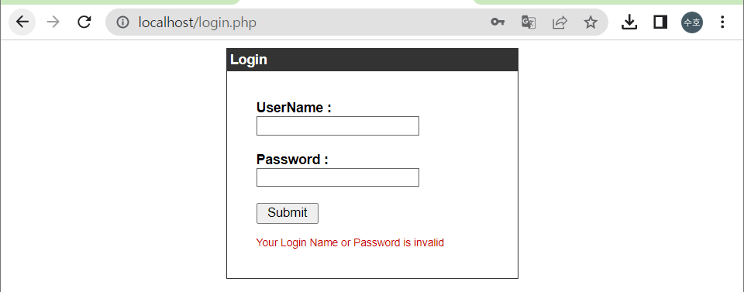

If I insert inappropriate paris of username and password, then the result came out like this.